COMP 7500 Lecture 04: Message-Passing Systems
: >85%, : 70-85%, : 55-70%, : 40-55%, : < 40%

Exercise 0 (MS Forms): Which one of the following mechanisms is the oldest IPC mechanism?
- Shared Memory
- Pipes
- Message Queue
- Signals
- Semaphore

Exercise 1 (MS Forms): What are the basic two operations of a message passing system?

Exercise 2: Please extend the two prototypes for direct communications.

Exercise 3 (MS Forms): Suppose you have implemented a message passing mechanism on a shared-memory system and a distributed-memory system, respectively. Which system is more scalable? Why? (30 Seconds)
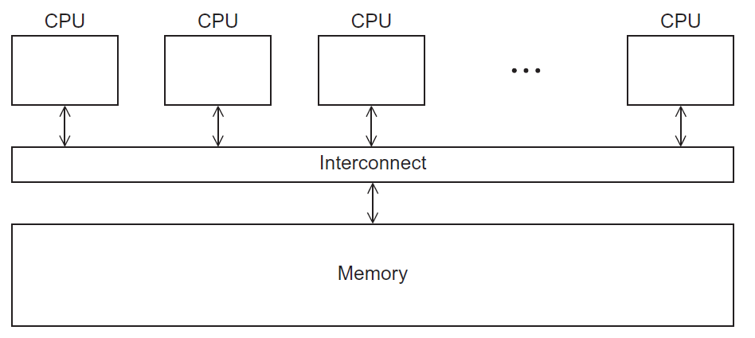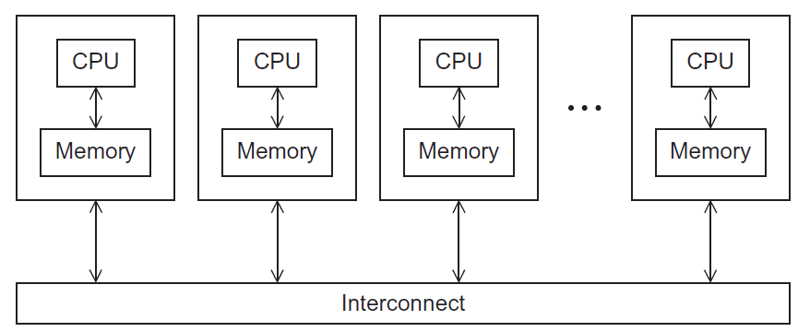

A) Shared-Memory System B) Distributed-Memory System
C) They are equally scalable D) Scalability can’t be measured

Exercise 4 (MS Forms): How should communicating processes be associated with a link in direct communication? Why? (30 Seconds)
- A link is associated with multiple pairs of processes
- A link is associated with exactly one pair of processes
- A link should be associated with any pair of processes
- A link is associated with a group of more than two processes

Exercise 5 (MS Forms): Is a link unidirectional or bi-directional in direct communication? Why? (30 Seconds)

- A link is unidirectional
- A link is bidirectional
- A link is neither unidirectional nor bidirectional
- A link has a hybrid mode: either unidirectional or bidirectional

Exercise 6 (MS Forms): How should communicating processes be associated with a link in indirect communication? (30 Seconds)

- A link is associated with multiple pairs of processes
- A link must only be associated with exactly one pair of processes
- No link should be associated with communicating processes
- A link is associated with a group of two or more processes

Exercise 7 (MS Forms): How many communication links should each pair of processes share? (30 Seconds)

- Each pair of processes may share several communication links
- Each pair of processes must share a single communication links
- Each pair of processes must share two communication links
- Each pair of processes must share three communication links

Exercise 8: What are the four basic operations for indirect communication? (30 Seconds)

Exercise 9: Please design the prototypes for the following two operations for indirect communication. (30 Seconds)

Exercise 10: There is a shared mailbox among P1, P2, and P3.
Suppose P1 sends a message to the mailbox, both P2 and P3 receive. Who gets the message? (30 Seconds)

